## **Cairo University**

## **Faculty of Computers & Artificial Intelligence**

## **Computer Science Department**

**Year 2021 – 2022**

**First Term**

**Lab 1**

**Protégé**

**Ontology Example**

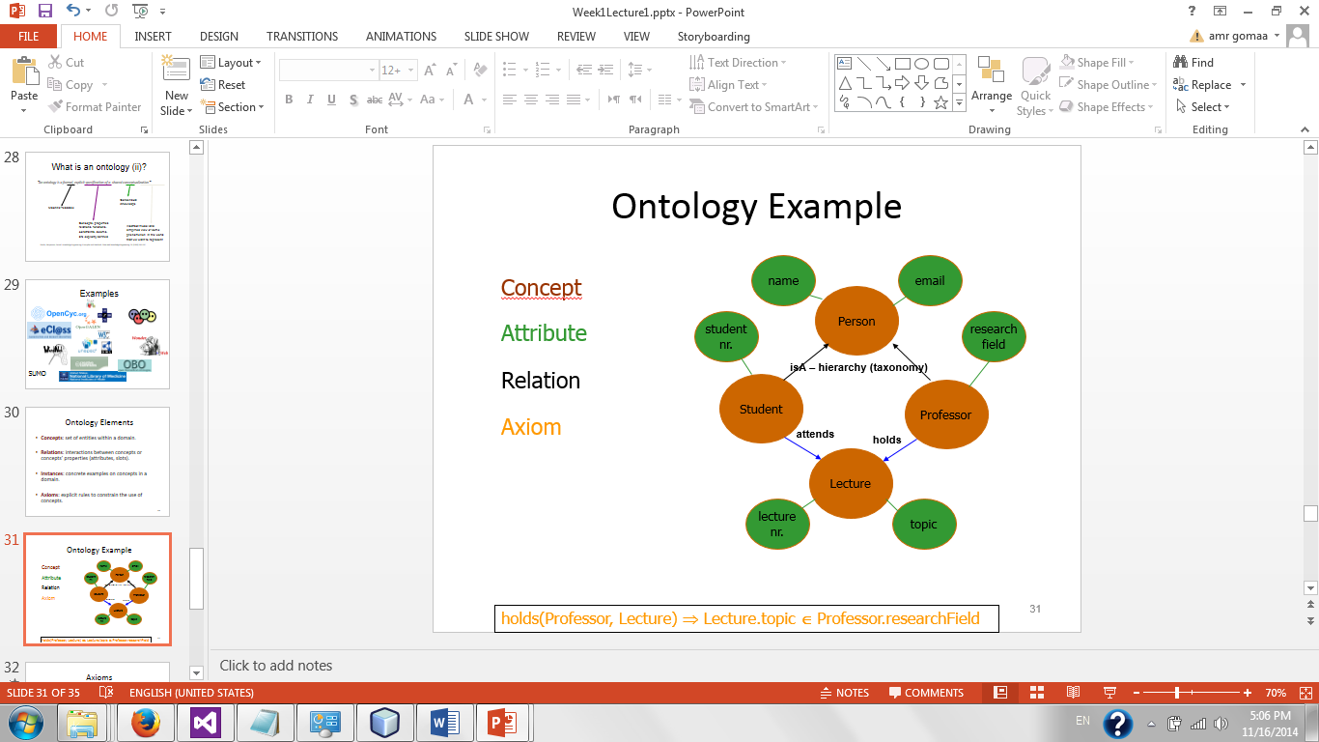

This is a party of the faculty individual’s ontology:

1. Class person that holds two data properties (name, email)
2. Class Students which is subclass of Person with one more data property (student num.)
3. Class Professor which is subclass of Person with one more data property (research field)
4. Class Lecture that holds two data properties (lecture num,topic)
5. An object property (attend) relates between a Student and a Lecture
6. An object property (holds) relates between a Professor and a Lecture

**Build this Ontology in Protégé**

**Step by step example:**

**Step 1:**

Define classes and their hierarchy:

1. Create class Person as a subclass of Thing (Abstract).
2. Create class Lecture as a subclass of Thing (Abstract).
3. Create class Professor as a subclass of Person (Concrete).
4. Create class Student as a subclass of Person (Concrete).

**Step 2:**

Define slots of each class:

1. Person (name, email).  *(create in data properties tab, then add property to class in classes tab)*
2. Student (student num).
3. Professor (research field).
4. Lecture (lecture num, topic).

**Step 3:**

Create object properties:

1. Attend (create in object properties tab, add Student as domain and Lecture as range)
2. Holds (create in properties tab, add Professor as domain and Lecture as range)